print(4, 8, 15, 16, 23, 42)  
print(4, 8, 15, 16, 23, 42, sep="\n")  
a = int(input())  
print(a + 1)  
print(a + 2)  
print()  
b = int(input())  
c = int(input())  
d = int(input())  
print(b+c+d)  
print()  
f = int(input())  
print(f**3)  
print(f**2*6)

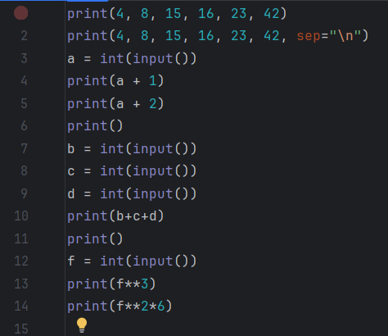

student = int(input())  
mandarine = int(input())  
if(student == 0):  
 print(student // mandarine)  
 print(student % mandarine)  
if (mandarine == 0):  
 print(0)  
 print(0)  
else:  
 print(mandarine//student)  
 print(mandarine%student)

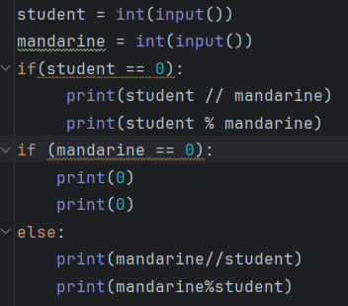

number = int(input("Enter a number: "))  
def find_digits(number):  
 if not (1000 <= number <= 9999):  
 return "Input must be a four-digit number."  
   
 thousands = number // 1000  
 hundreds = (number // 100) % 10  
 tens = (number // 10) % 10  
 units = number % 10  
  
 print(f"The digit in the thousands position is {thousands}")  
 print(f"The digit in the hundreds position is {hundreds}")  
 print(f"The digit in the tens position is {tens}")  
 print(f"The digit in the position of units is {units}")  
  
find_digits(number)

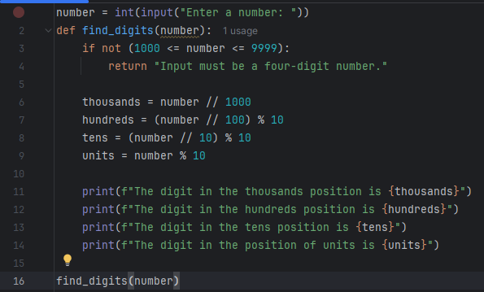

population = int(input("Enter a population size: "))  
def count_survivors(population):  
 survivors = population / 2  
 survivors = int(survivors) if population % 2 == 0 else int(survivors) + 1  
 return survivors  
  
print(count_survivors(population))

